TUGAS JOIN, RIGHT JOIN, LEFT JOIN

**MOHAMAD ARDIANSYAH ROFII**

1. **SELECT id_pembeli, nama_pembeli, pembeli.id_obat, nama_obat**

**FROM `pembeli`**

**JOIN obat ON pembeli.id_obat = obat.id_obat**

**ORDER BY id_obat ASC**

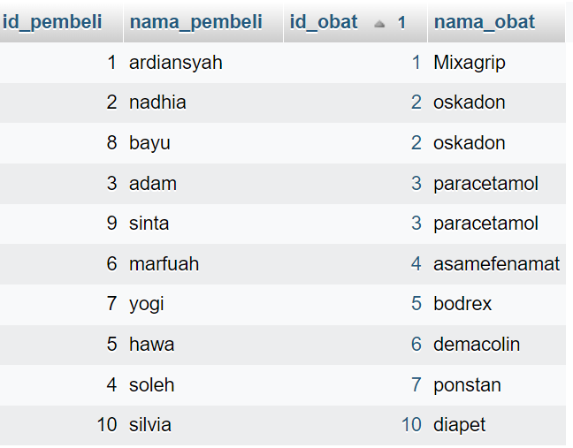

1. **SELECT id_pembeli, nama_pembeli, umur, pembeli.id_obat, nama_obat**

**FROM `pembeli`**

**JOIN obat ON pembeli.id_obat = obat.id_obat**

**WHERE umur <= 50**

**ORDER BY id_obat ASC**

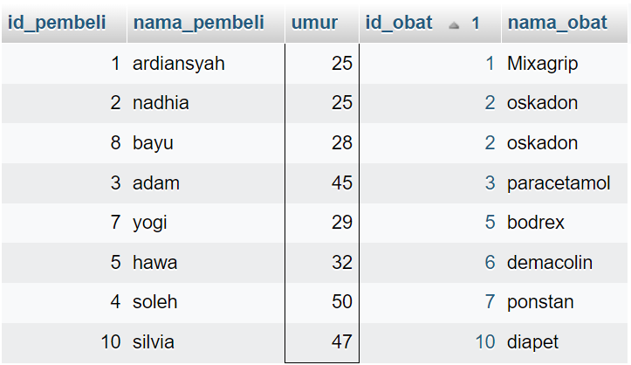

1. **SELECT id_pembeli, nama_pembeli, umur, jenis_kelamin, pembeli.id_obat, nama_obat**

**FROM `pembeli`**

**JOIN obat ON pembeli.id_obat = obat.id_obat**

**WHERE umur <= 50 AND jenis_kelamin = 'L'**

**ORDER BY id_obat ASC**

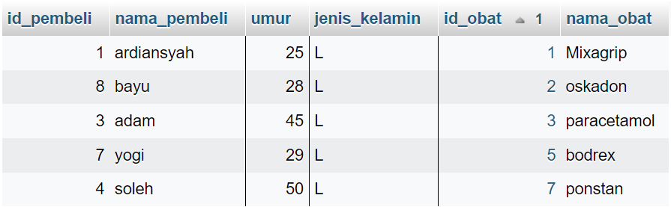

1. **SELECT id_pembeli, nama_pembeli, umur, jenis_kelamin, pembeli.id_obat, nama_obat**

**FROM `pembeli`**

**RIGHT JOIN obat ON pembeli.id_obat = obat.id_obat**

**ORDER BY id_obat ASC**

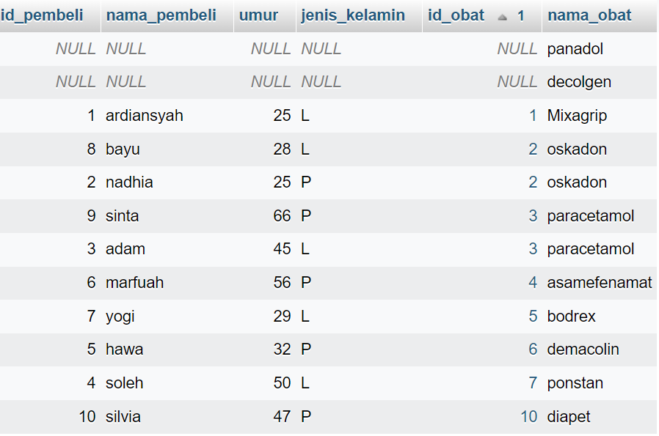

1. **SELECT id_pembeli, nama_pembeli, umur, alamat, jenis_kelamin, pembeli.id_obat, nama_obat, harga**

**FROM `pembeli`**

**LEFT JOIN obat ON pembeli.id_obat = obat.id_obat**

**ORDER BY id_obat ASC**

